***Assignment 2***

***22-11063***

Test 1:

The test is supposed to Pass on executing the below code snippet as both the expected and the actual string values match.

Code:

|  |
| --- |
| package demo.tests;  import static org.junit.Assert.*;  import org.junit.After;  import org.junit.Before;  import org.junit.Test;  public class JUnitProgram {      @Test      public void test_JUnit() {          System.out.println("This is the testcase in this class");          String str1="This is the testcase in this class";          assertEquals("This is the testcase in this class", str1);      }  } |

The result on console and JUnit Result Tab:

On executing the JUnit class, the console and JUnit result tab shows up,

* The Console shows as below where a message reads as ‘This is the test case in this class’.
* The JUnit result tab displays mainly the number of test cases run, number of errors and number of failures encountered i.e. Run: 1/1 (meaning 1 testcase out of 1 testcase ran), Errors: 0 (no errors found in the test case executed), Failures: 0(no test cases failed)
* The time taken to finish the execution of the tests.
* Displays a green bar if all the test cases are passed.
* Just above the timestamp on the JUnit tab, you see different icons: The first icon shows ‘Next Failed Test’, the second icon shows ‘Previous Failed Test’, and the third icon with a blue and red cross helps you to filter out only failed tests. The icon next to this is to filter only the test cases that were skipped during execution.

[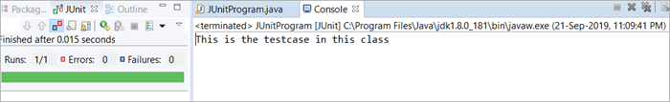](https://www.softwaretestinghelp.com/wp-content/qa/uploads/2019/11/Image6-1.png)

Test 2:

Now, let’s make a slight update to the code such that the expected string value doesn’t match the actual. The test is supposed to Fail on executing the updated code snippet as both the expected and the actual string values do not match. In the screenshot below, you can see the updated code as well as the resultant tab.

Result on console and JUnit Result Tab:

On executing the JUnit class, the console and JUnit result tab shows up the below.

* The Console message and timestamp under the JUnit result tab display as it was in the earlier example.
* The difference with this change is in the JUnit results tab. The Failures count now shows 1, with a red bar implying that the testcase has failed. Given below is a screenshot for your reference.

[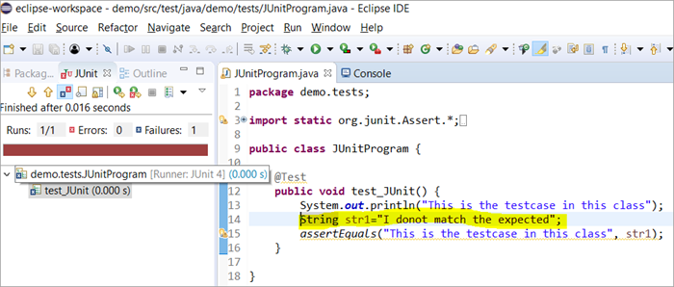](https://www.softwaretestinghelp.com/wp-content/qa/uploads/2019/11/Image7.png)

* At the bottom of the Left panel, there is a ‘Failure Trace’ tab that shows the reason why the testcase failed.
* When you click on the first line under the Failure Trace, a window that shows the deviation between the expected results and actual results very clearly opens up.

Screenshot of the deviation window is shown below:

[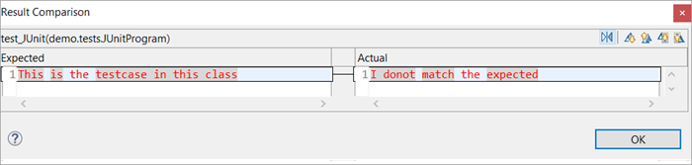](https://www.softwaretestinghelp.com/wp-content/qa/uploads/2019/11/Image8.png)

Save Failed Tests And Stacktraces

* On the failed test under the JUnit result view, navigate to the Failure Trace tab, right-click and select the option ‘Copy Failure List’.
* You will be able to paste it in a notepad or word and save it for your future reference. The copy pasted content includes all the stack traces of this failed instance of the testcase along with the testcase name.

[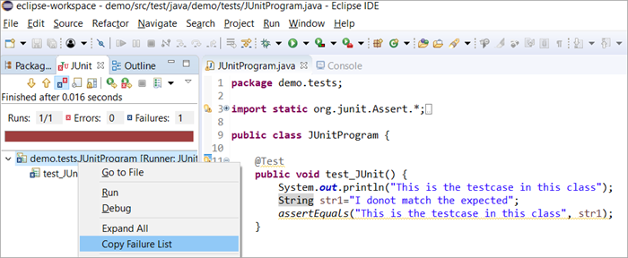](https://www.softwaretestinghelp.com/wp-content/qa/uploads/2019/11/Image9.png)